Aws Challenges

* Launch one **EC2 instance** using **Amazon Linux 2**.
* Install **Docker**.
* Create one ec2 instance and use a pem key and pubic id to connect the remote server
* Yum sudo update then install docker
* Then check the status
* Then use command of sudo systemctl start docker
* Then check the status again systemctl status docker

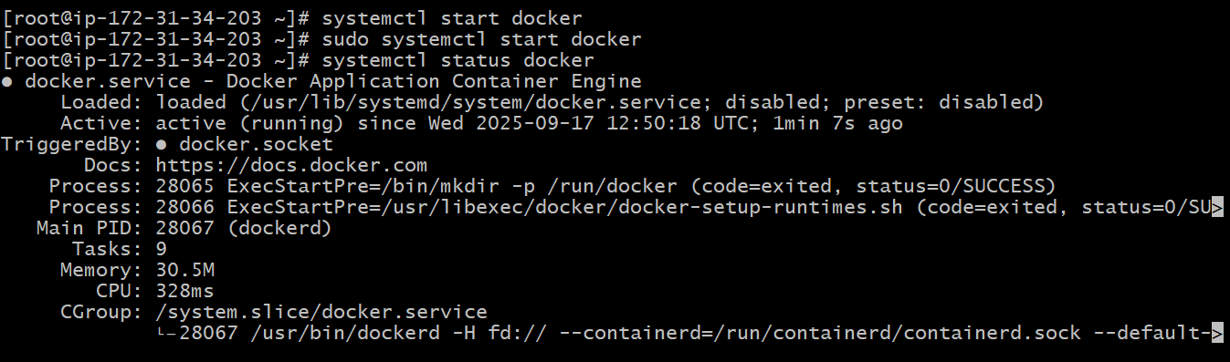

* Then enable the docker.



* Install **Jenkins**.
* if we want to run any jenkins we need install java first
* "sudo yum install java-17-amazon-corretto -y"
* use the link for java download then
* open linux.io install jenkins then follow the steps:
* "sudo wget -O /etc/yum.repos.d/jenkins.repo \
* https://pkg.jenkins.io/redhat-stable/jenkins.repo"
* use this first.
* "sudo rpm --import https://pkg.jenkins.io/redhat-stable/jenkins.io-2023.key"
* then sudo yum upgrade
* then sudo yum install jenkins then
* use this commands:
* sudo systemctl daemon-reload
* sudo systemctl restart jenkins
* sudo systemctl status jenkins
* nd copy the public ip and open a browser nd paste it and give a 8080 port nd run
* it will show the page with password
* for that copy the link where shown in web page and nd "cat copy the link"
* it will gave uh a password
* copy the password it will gave uh open page of jenkins.

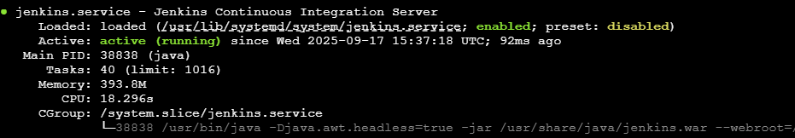

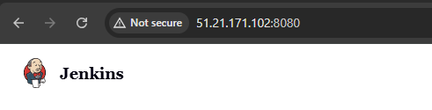

* Install **Apache**.
* If we want to apache server we need to java install manditory
* Then check the version of java
* Then install apache
* Check the status
* Nd start the apache
* Nd check the status again and enable the the apache
* Then open a browser gave port number 80
* It will show uh the result…

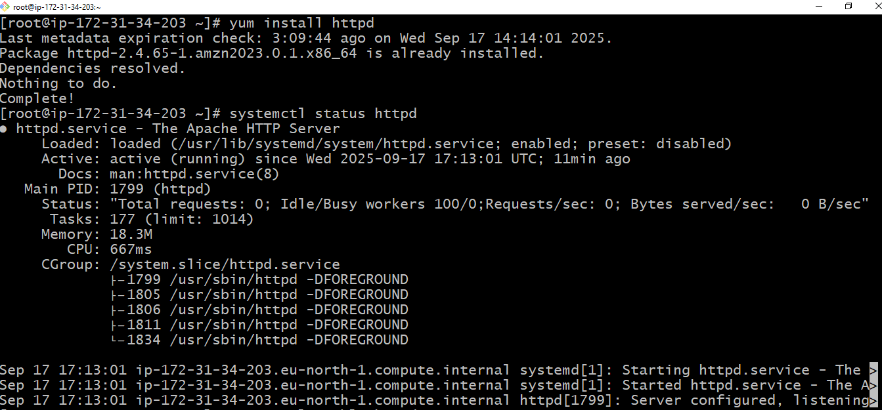

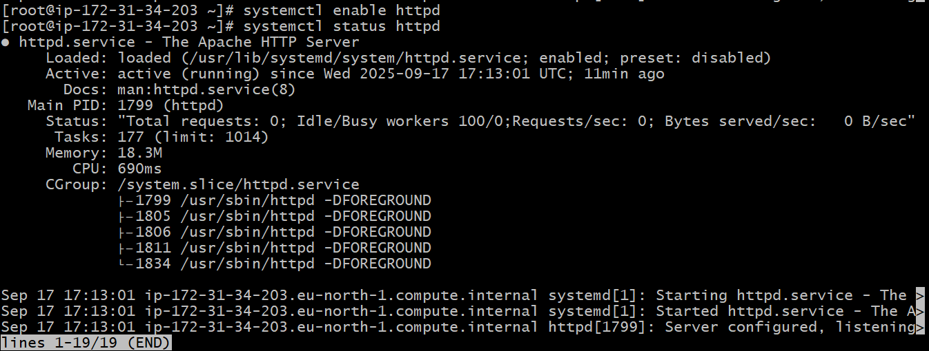

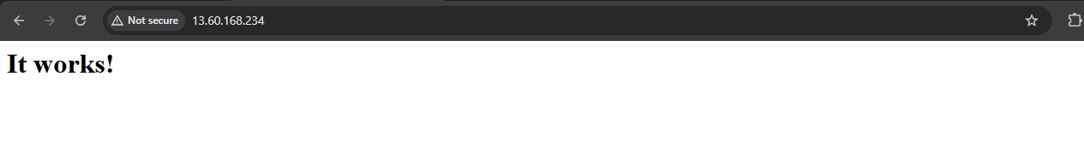

* Install **Nginx**.

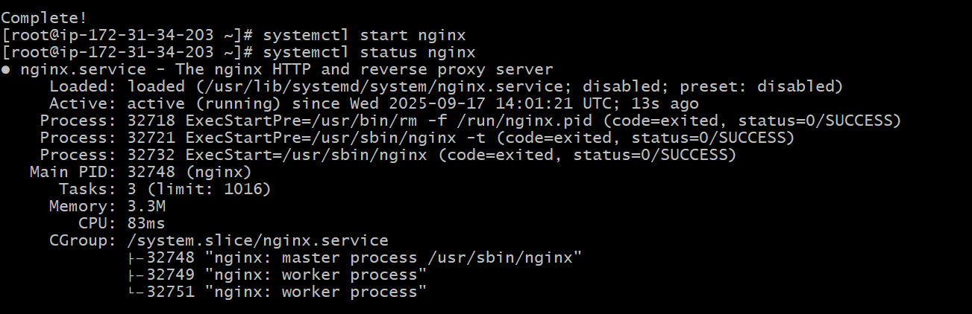



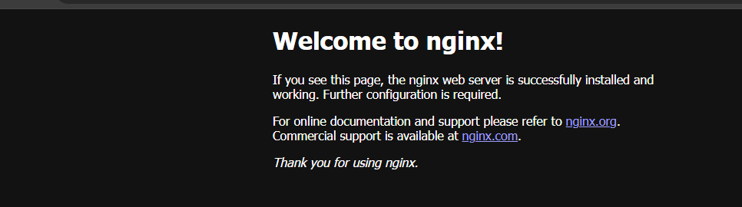

* Install **Apache Tomcat**.
* first open a browser then open a apache
* tomcat web page and take the tar copy link and
* open a git bash wget copy the link
* then it will installed then press ls
* they will show two extract files
* then use a command of tar xvzf ap nd tab
* ls
* cd ap nd tab enter
* cd bin/
* ls
* ./startup.sh
* cd ..
* ll
* cd conf/
* ll
* cat server.xml
* vi server.xml then chng the port in listen
* ls
* cd ..
* cd bin/
* ls
* ./shutdown.sh
* ./startup.sh
* then check in browser with public id and port number
* which uh gave in security inbound rules...

